From: Yeo Wei Khoon [mailto:wei-khoon.yeo@dbschenker.com]
Sent: Tuesday, 01 April, 2014 1:32 PM
To: Pei Fong Chan
Cc: khang-hwee.tan@dbschenker.com; davidgh.lim@dbschenker.com
Subject: WMS Hub Loading

Hi PeiFong,

We would like to improve on the accuracy on the Hub loading as we still have problem of sending the goods wrongly to customer.
Please see below on the 2 things which we would like to change , is it possible?

1. Check on the loading base on ‘Ship to Party’ instead of ‘sold to Party’
2. Scanning the HU 2 times instead of 1 time when loading the container.

Current loading :  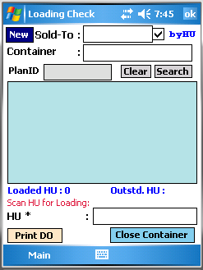 | To change:  1. Validate by Ship-to  - System DO loading checking for allowing consolidate by Ship-to  (Setup by Carrier and MOT in WMS)  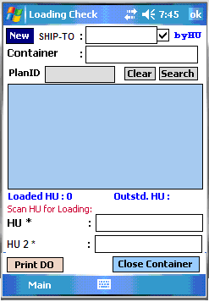  2. Add secondary scanning  - validate 1st HU and 2nd HU must be same.  - if not same then system will reject the HU,

WMS changes
1. HUB- Shipment Release
To add ship-to code.

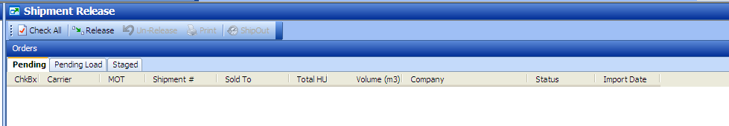
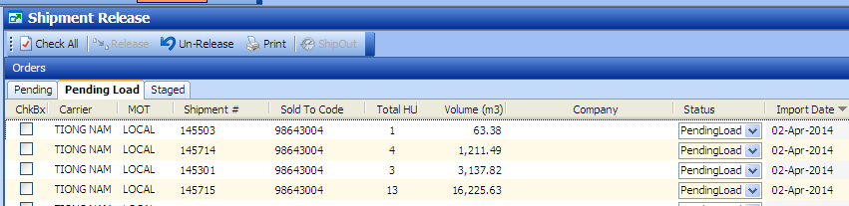

2. Loading Maintenance / DO
- Add Ship-to

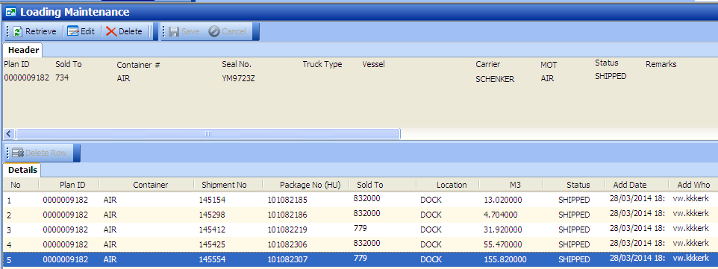

3. Carrier and MOT setup
Set Long = 1 -> to allow consolidate multiple ship-to(s) into same DO
Set Long = 0 -> to disallow consolidate DO by Ship-to

